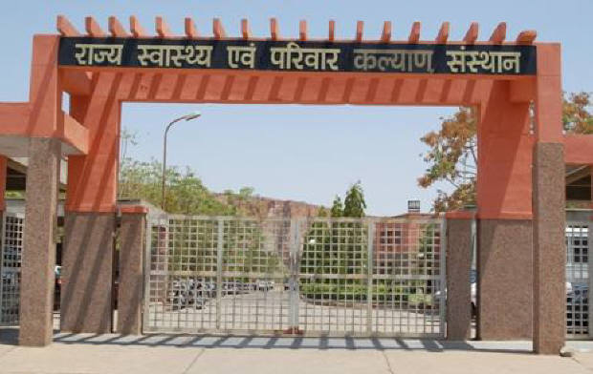
SIHFW Rajasthan

Electronic Newsletter
January to March 2026 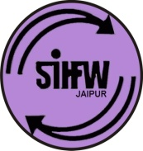
SIHFW: an ISO 9001:2015 certified Institution
From the Director’s desk…
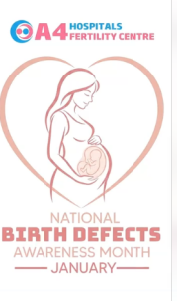
Dear Friends…

The year 2026 began with January month as every calender year, but with a difference that January month was also recognized as National Birth Defects Awareness Month. It was considered a time to raise awareness about birth defects, their prevention and early care. Birth defects can affect any family but with proper prenatal care, balanced nutrition, folic acid intake and timely medial guidance many risks can be reduced. Awareness and education play a role in supporting healthy pregnancies and strong beginnings. This month was recognized to remind each one of us that every journey matters-from planning pregnancy to prenatal care and beyond. Let’s support families, spread awareness and work together for healthier mothers and babies.

This newsletter carries information on important activities organised during January to March 2026 and since we have crossed financial year 2025-26 (March 2026) we have also included annual progress of various trainings.

Best Wishes!!

Dr. Pushpa Chaudhary
Registrar-SIHFW

Some important health and social days for January to April 2026
World Leprosy Day -Jan 25, 2026 (last Sunday of January)  In India World Leprosy Day is celebrated on 30 January, marking the death anniversary of Mahatma Gandhi | World Health Day-April 7, 2026
World Cancer Day Feb 4, 2026 | World Parkinson Day-April 11, 2026
National Safety Day- March 4, 2026 | National Safe Motherhood Day-April 11, 2026
International Women’s Day -March 8, 2026 | World Hemophilia Day-April 17, 2026
World Kidney Day-March 14, 2026  (second Thursday of March) | Earth Day-April 22, 2026
World Down Syndrome Day-March 21, 2026 | World Malaria Day-April 25, 2026
World Tuberculosis Day -March 24, 2026 | World Day for Safety and Health at Work-April 28, 2026
World Autism Awareness Day –April 2, 2026 | World Birth Defects Day-March 3, 2026
India- National Birth Defect Awareness Month 2026-January
Workshops at SIHFW
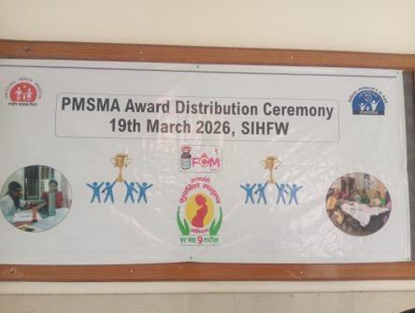
PMSMA Award Function
A Ceremony of 1 day was organised at SIHFW. This Award Distribution Ceremony was organized on 19.3.2026.
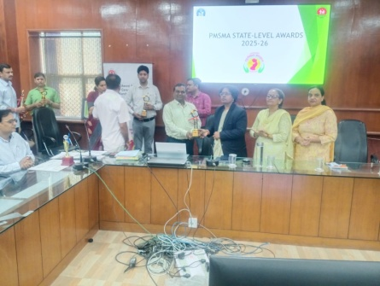
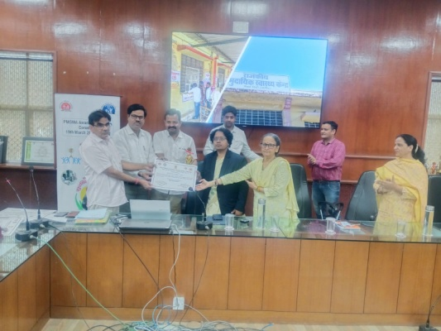
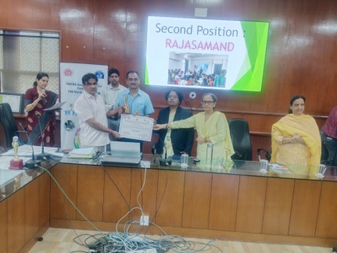

Orientation Workshop under National Program for Climate Change and Human Health (NPCCHH)
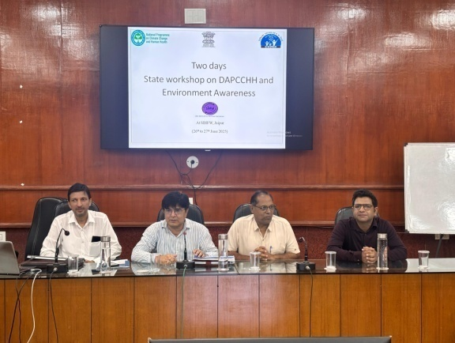
This was a 2 days workshop organised at SIHFW on June 26-27, 2025. Main components of this workshop included Impact of air pollution on human health, disaster management, Lead poisoning scenario, challenges and way forward. During this workshop participants were oriented on District Action Plan on Climate Change and Human Health. There were presentations on Model District Action Plan by districts. Workshop also has discussions on the success stories of Heat wave preparation and management. Roles and responsibilities of Deputy CMHO (Health) were also discussed. 39 participants were trained in this training.
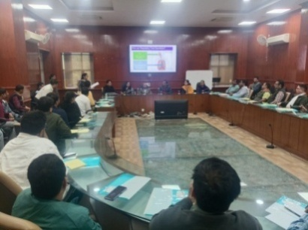
World TB Day Celebration and Multi-Sectoral Meeting was organized at SIHFW on 25.03.2026

National Workshop on Strengthening Capacity on Quality Palliative Care
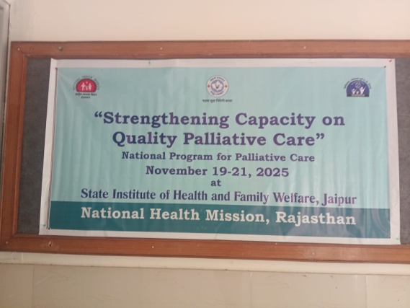
This was a 3 days workshop organised by NHM –Rajasthan in coordination with SIHFW. This workshop was organised on November 19 to 21, 2025. There were 28 participants including Specialists, SMOs and MOs. Out of 28, 10 participants were from other states of the country- Haryana, Gujarat, Bihar and Uttarpradesh. This was a capacity building workshop and on first day classroom sessions were organised and in other two days hands-on sessions were organised at centre for palliative care and medicine, SMS Medical College and Hospital, Jaipur. Key topics covered in this training workshop included Objective and Goal of NPPC, Management of Respiratory Symptoms, Palliative Care Emergencies, Assessment of Pain, Strong Opiods for cancer pain management, End of Life care, Management of GI symptoms, Communicating effectively, Diet and Nutrition, Record Keeping, Home based care and Home based care model of Rajasthan, Morbidity and data in NPPC. There were discussion and demonstration on management of wounds, ostomies and oral care.
Component wise Trainings of SIHFW
SIHFW is provided Administrative and Financial Sanctions for trainings by NHM. These sanctions are based on approvals under PIP, as approved by GoI. Some training are organized at SIHFW and some are further sanctioned to Zones and Districts by SIHFW. In both types of trainings, according to nature of trainings, sessions are organized at Medical College hospitals, District hospitals or any other hospitals selected as a venue for practice sessions. Demonstrations and hands-on sessions on dummies are also organized at SIHFW skill lab. Key components of trainings implemented by SIHFW are following:
- Maternal Health and Family Planning
- Child Health and Immunization
- Adolescent Health (RKSK)
- National Health Programs
- Foundation Training for newly recruited Medical Officers
- Gender Violence
- Bio-Medical Waste Management
- Ayushman Bharat Program
- Blood Storage
- Community Engagement and Processes and HMIS
- Quality Assurance
Following are the details of training organised under each of the above training components:

Maternal Health and Family Planning

- Training of Medical Officers in Safe abortion is a 12 days training organized at Medical College and Districts. 55 batches are completed.
- Dakshta ToT is a 5 days training organized at SIHFW. 1 batch was organized.
- PMSMA is organized for 1 day at SIHFW. 1 batch was organized.
- Maternal Death Review Training is of one day and organized at SIHFW. 1 batch was organized.
- MMA Training is of 3 days duration and organized at District Hospital and Medical College. 19 batches were organised.
- Laparoscopic Sterilization Training for doctors if of 12 days duration and organized at District Hospital and Medical College. 3 batches were organised.
- Minilap Training for MOs is of 12 days duration and organized at District Hospital and Medical College. 1 batch was organised.
- NSV Training for MOs is of 5 days and organized at District Hospital and Medical College. 3 batches were organised.
- ToT on New Contraceptives (Antara & Chhaya) is of 2 days and organized at SIHFW. 1 batch was organized.
- Training of RMNCH/FP Counselors is of 1 day and organized at SIHFW. 1 batch was organized.
- RKSK Counselor Orientation Workshop for FP is of 1 day and organized at SIHFW. 1 batch was organized.
Child Health and Immunization
- RBSK (Committed) is of 2 days and organized at SIHFW. 10 batches were organized.
- ToT FIMNCI is of 5 days organized at SIHFW. 1 batch was organized.
- FIMNCI Training for MOs is of 5 days organized at SIHFW. 4 batches were organized.
- FIMNCI Training for SN is of 5 days organized at SIHFW. 3 batches were organized.
- ToT NSSK is of 2 days and organized at SIHFW. 1 batch was organized.
- NSSK Training for MOs is of 2 days and organized at SIHFW. 7 batches were organized.
- NSSK Training for SN is of 2 days and organized at SIHFW. 12 batches were organized.
- NSSK Training for ANM is of 2 days and organized at SIHFW. 15 batches were organized.
- IMNCI Training for MOs/SN is of 5 days organized at SIHFW. 138 batches were organized.
- IMNCI Training for CHO/ANM is of 5 days organized at SIHFW. 668 batches were organized.
- TOT IMNCI (Committed) is of 5 days organized at SIHFW. 1 batch was organized.
- HBYC ToT is of 5 days organized at SIHFW. 1 batch was organized.
- One day Orientation of Block Level Officials of Health ICDS & School on AMB (Committed) is of 1 day organized at Block level. About 40% of this training is completed.
- One Day Orientation of Block Level FLWs and PEEO on AMB (Committed) is of 1 day organized at Block level. About 40% of this training is completed.
- Routine immunization Training for HWs is of 2 days and organized at Districts. 97 batches are completed.
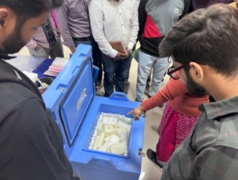
- Routine immunization Training for MOs is of 3 days organized at SIHFW. 29 batches are completed.
- EVM improvement Plan Workshop (Committed for FY 24-25) is organized at SIHFW is of 2 days and organized at SIHFW. 1 batch was organized.
- Orientation of Block Level Officials is of 2 days and organized at SIHFW. 10 batches were organized.
- EVM Assessment (Review and Finalization of report) one visit was organised to New Delhi.
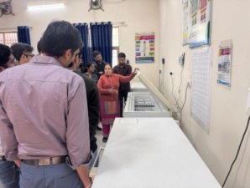
Routine Immunization Training for Medical Officers

Adolescent Health (RKSK)
- Adolescent Friendly Health Services (AFHS) Training of MOs is of 4 days and organized at SIHFW. 4 batches were completed.

- AFHS Training of ANM/LHV is of 5 days and organized at Districts. 5 batches were completed.

- PE Training at Block Level is of 6 days and organized at Block Level for Banawara, Bundi,Karauli, Jalore, Udaipur, Sanchor, Salumber and 173 batches were completed.

National Health Program
- Training of Medical Officers (NMHP) is of 5 days organized at SIHFW. 10 batches are completed.
- ToT under NMHP is of 5 days organized at SIHFW. 1 batch organised.
- Training of ASHA/ANM/Dental and paramedical staff (NOHP) is of 1 days and organized at Districts and 2 batches are completed.
- Capacity building incl. Training (NPPC) is of 3 days organized at SIHFW. 18 batches are completed.
- Capacity building incl. Training (NPPCD) is of 3 days and organized at SIHFW. 15 batches are completed.
- Malaria - capacity building incl. Training (NVBDCP) is of 3 days and organized at SIHFW. 10 batches completed.
- Dengue & Chikungunya - capacity building incl. Training (NVBDCP) is of 3 days and organized at SIHFW. 4 batches completed.
- Capacity building incl. Training (NP-NCD) is of 4 days organized at SIHFW. 17 batches are completed.
- NPCCHH is of 2 days organized at SIHFW. 1 batch is organized.
- NRCP Sub Activity Capacity building (Training of MOs and HWs) is of 2 days organized at SIHFW and Districts. 1 batch was organized.
- National Programme for Prevention and management for trauma & burn injury (NCD) is of 1 day and organized at SIHFW. 2 batches were organized.
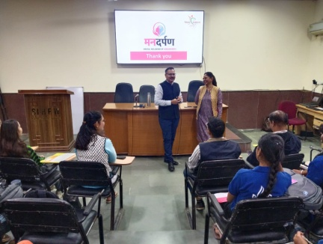
Felicitation of NSS Volunteers for Mental Health Week Activities
This activity was done in coordination with UNICEF . Those students who coordinated some activities during Mental awareness week, were felicitated with certificates.

Foundation Training for newly recruited Medical Officers
This is a 12 day training provided to newly recruited Medical Officers. Objective of this training is to orient the newly recruited MOs to learn about the various health programmes and schemes, latest guidelines, Acts, rules and regulations and government procedures, which they have to perform as a Medical officer. The training focuses on sharpening administrative skills of MOs along with clinical roles and responsibilities.

Participants were also taken on field visits to observe UPHC Gandhinagar for Quality Assessment and Certification Process. Participants are given hands on exposure in skill lab of SIHFW on various work stations and with dummies. Till December 5 batches of Foundation training were organised and 131 newly recruited Medical officers were trained in this training.

Gender Violence
These trainings are organised at zonal level and 10 batches are completed till March 2026. Before organizing trainings at zones, 2 batches of ToT were organised at SIHFW to develop trainers for zonal training. At zonal level Medical Officers and Nursing staff are trained on gender based violence and medico legal care for survivors’ victims of sexual violence.
Bio-Medical Waste Management
These trainings are organised at zonal level and 8 batches are completed till March 2026. Before organizing trainings at zones, 2 batches of ToT were organised at SIHFW to develop trainers for zonal training.
Ayushman Bharat Program
- One day training of Medical Officers on Eat Right at District Level. It is organized at Districts and 20 batches are completed.
- 12 Days Residential training of PHC-HWC Medical Officers on Elderly and palliative care, Mental health, Oral Care, Eye/ENT/Emergency Care. It is organized at zones and 6 batches are completed.
- Training of CHOs on Expended Range of Services. It is of 12 days and organized at District and SIHFW. 34 batches are completed.
- Training of CHOs on 15 Days Induction. It is organized at SIHFW and Districts. 35 batches are completed.
- Training of CHOs on EAT Right. It is of 1 day and organized at Districts. 39 batches are completed.
- Training cum ABDM workshop at District Level and IEC activity under ABDM. It is of 1 day and organized at SIHFW. 21 batches are completed.
Expanded services training for AAM-Medical Officers
These trainings were organised at zonal level for Medical officers posted at Ayushman Arogya centres. In these 12 days trainings MOs are trained on Elderly and palliative care, Mental health, Oral Care, Eye, ENT and Emergency Care.
Training for Community Health Officers (CHO)
At present two types of trainings are being organised by SIHFW under Ayushman Bharat Program. CHOs Induction Training is organised for 15 days for newly recruited Medical Officers. These batches are being organised at SIHFW and few select districts. After this training, CHOs have to undergo 12 days training on Expanded Services (MNS, Elderly, Palliative, Oral, Eye, ENT and Emergency Care). These trainings are organised at SIHFW and districts.
Blood Storage
Blood storage Unit staff are given 3 days orientation and hands on training on management of Blood Storage Unit. 5 batches as planned are completed by SIHFW. This training is organised for Medical Officers, Laboratory Technicians for duration of 3 days. It is organised by SIHFW at SDMH, Jaipur. Training methodology includes demonstration, clinical hands on practice, classroom. The trainings goal is to develop trained manpower of Medical Officers/LT for managing blood storage.
Community Engagement and Processes and HMIS
- State Level TOT on PLA for strengthening VHSNC. It is of 3 days and organized at SIHFW. 2 batches were completed.
- District level TOT on PLA for strengthening VHSNC. It is of 3 days and organized at SIHFW. 26 batches were completed.
- State ToT (CAH). It is of 2 days duration and organized at SIHFW. 2 batches were organized.
- District ToT (CAH) ). It is of 2 days duration and organized at SIHFW. 7 batches were completed.
- MCTS/HMIS Capacity building and Review meeting (state Level). It was of 1 day meeting organized at SIHFW. 6 such meetings have been organized.
- Hand book Training Module of ASHA Facilitator. This is of 2 days and organized at SIHFW. 6 batches were completed.
- ASHA Module 6&7 Refresher ToT. It is of 6 days organized at SIHFW. 5 batches have been completed.
- ASHA Module 6&7 ToT (Hybrid mode). It is of 15 days, organized in hybrid mode (8 days Online + 7 days Offline) organized at SIHFW. 2 batches are completed.
ToT of District ASHA Trainers

This training is at present longest duration training organized at SIHFW. This is a 15 days Hybrid training where 8 days online sessions are organized and 7 day offline sessions are organized at SIHFW. 2 training batches were organized at SIHFW during this financial year and 44 participants were trained in this ToT. During offline sessions, participants are trained on skill hands-on practice, with skill demonstration. Participants appear in skill assessments based on OSCI, mock sessions and written paper. Only when participants qualify passing marks, they can become District trainers to give training to ASHA workers. Training methodology also includes Case discussions, written assignments, Role play, lecture methods, etc.

ASHA Refresher ToT training

ASHA Refresher ToT training is organized under ASHA Program. This is a six day training organized for refreshing knowledge of District ASHA trainers and mentoring and facilitation staff including ANM/SHS, etc. This training develops better supervision skills in facilitators to provide hand holding for ASHA workers. 5 batches were organised and 105 participants were trained.

Handbook Training for ASHA Facilitators
This is a two days training for ASHA facilitators organized at SIHFW. It is of 2 days. Participants are trained on key topics of community processes and supportive supervision. 6 batches have been organized and 142 participants were trained in this training.
ToT on PLA for VHSNC Program
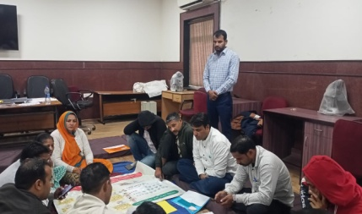
This ToT is organised on Participatory Learning in Action (PLA). This training is organised at SIHFW with technical support of Ekjut. Participants will organize PLA sessions at field level involving community members and field functionaries.
Role plays are organised on VHSNC meetings and Community Meetings. These dummy meetings are organised on various themes such as PLA, Identification of problems and preparing strategies, Family Planning, Safe Abortion, Nutrition, etc. BHS, PHS and CHOs are participants in these trainings. State ToT was organised on Phase –V focused on Immunization and Child Health. 2 batches of State ToT and 26 batches of District ToT have been organized at SIHFW during this financial year.

Quality Assurance
- Training of Service providers cum Internal Assessors under NQAS. It is of 3 days and organized at SIHFW. 1 batch was organized.
- Training on NQAS is also of 3 days duration and organized at SIHFW. 3 batches were organized.

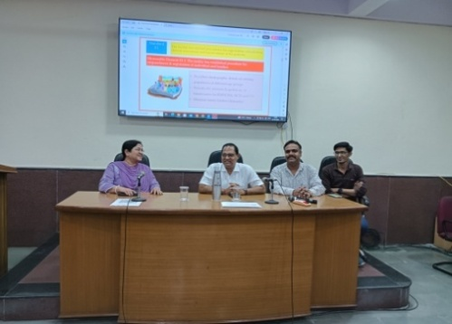
Service Providers Training on National Quality Assurance Program (NQAS)
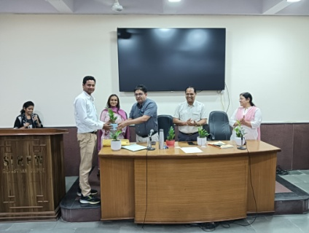
This is a 3- days training of service providers on National Quality Assurance Program, organised at SIHFW. Assessors, trainers participate at this training. This training is organized to develop knowledge of quality standards and assessments formats.

Research Study

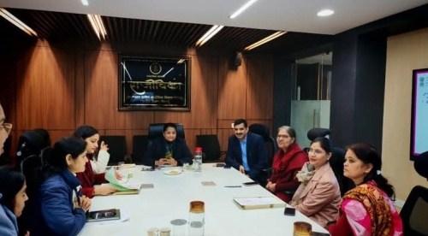
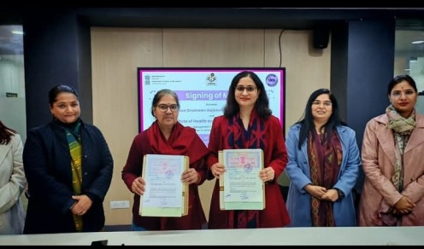
“Baseline Study of the FNHW Interventions at Immersion sites under State Rural Livelihood Mission, Rajasthan” has been conducted by SIHFW. MoU for this study was done between SIHFW and Rajeevika on January 6, 2026. Summary of findings have been submitted to Rajasthan Grameen Aajeevika Vikas Parishad-RGAVP at Jaipur. Data has been collected in this study from 3 districts-Hanumangarh, Karauli and Sawai Madhopur. The study is done on basis of interviews of Officials, Field workers and women members of SHG groups such as mothers of 0-6 months infants, mothers of 7 to 24 months, pregnant women and Adolescent girls. Data collection from respondents was done with help of mobile based digital tool for quantitative data. Qualitative data has been collected in this study through Focused Group Discussions and documentation of success stories. Team of SIHFW facilitators and freelance researchers have collected the data. Dr Pushpa Choudhary, Registrar, SIHFW signed the MoU on behalf of SIHFW, and researchers Dr Ajapa Bhardwaj and Dr Rajni Singh of SIHFW were also present at the MoU signing event.

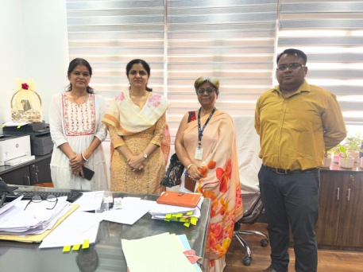
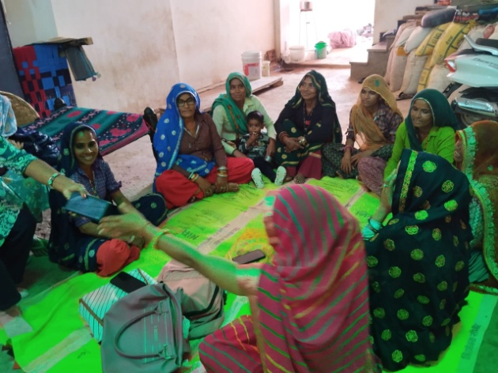
MoU signing meeting

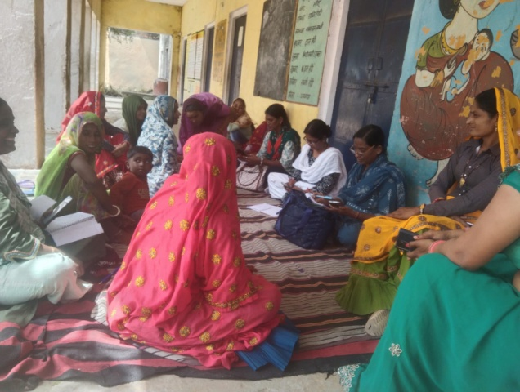

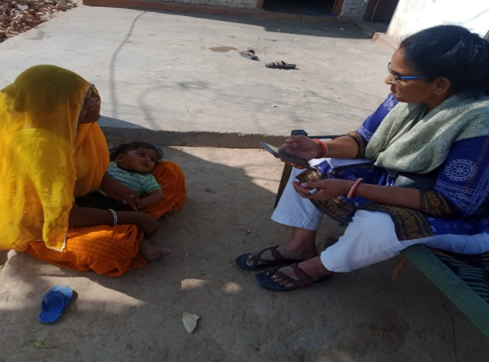
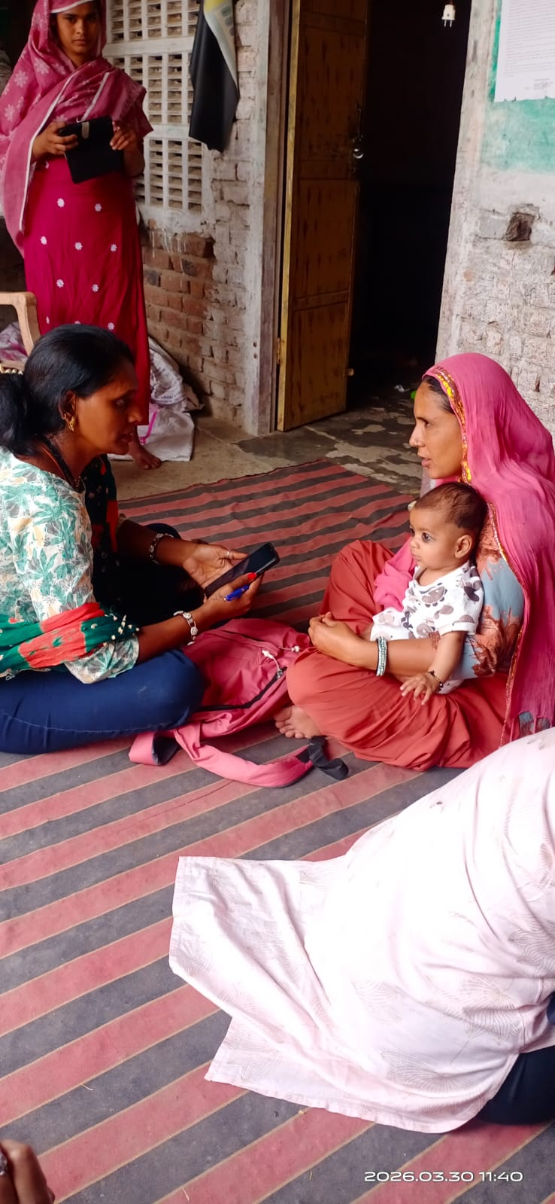
Interviews of State Officials

Focused Group Discussions and Data Collection
Staff Meetings at SIHFW
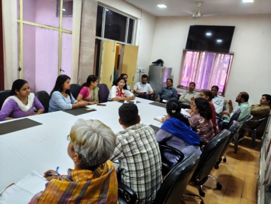
Staff Meetings are organized at SIHFW in a periodic manner to discuss progress and get faculty feedbacks. It also provides opportunity for cross learning within the teams. Meetings were organized on 4.2.2026, 8.4.2026, 17.4.2026.
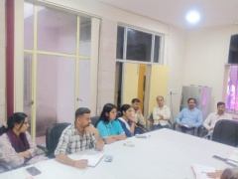
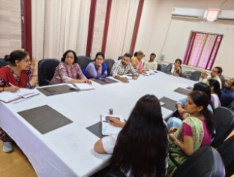
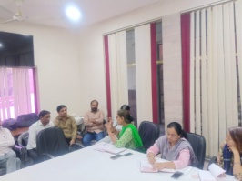

Glimpses of field training photographs
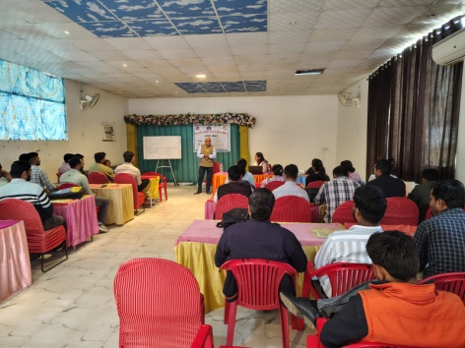
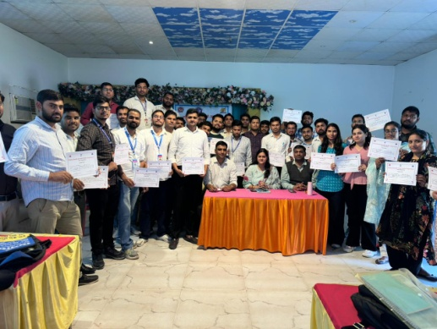
CHO Induction and CHO Expanded services training at Alwar.

Participation from SIHFW
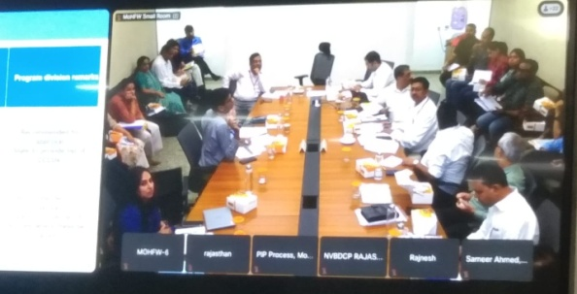
Participation at Pre NPCC
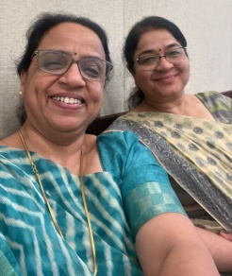
Pre NPCC meeting is organized at the end of financial year at MoHFW, GoI to plan NHM PIP for the next year ie.e 2026-27. This year, representative of SIHFW, Dr Bharti Sharma, Faculty also participated with NHM Officials and consultants. Meeting for Rajasthan state was scheduled on March 16, 2026. NHSRC representatives and experts also participated in discussions. This year SIHFW team is involved in PIP planning of integrated trainings.
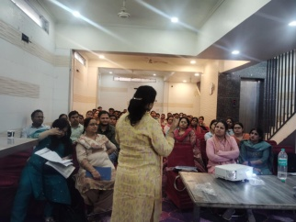
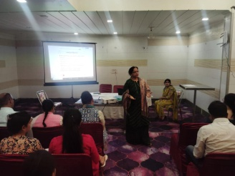
Dr Bharti Sharma, Faculty SIHFW delivered training sessions at Quality ANC training organised by CMHO Jaipur.

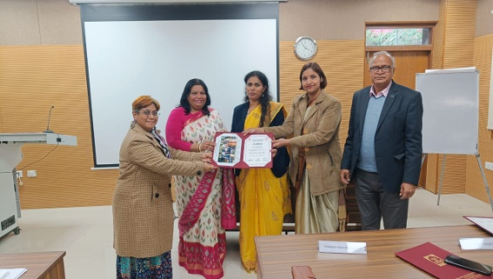
Direct Trainer’s Skills (DTS)
Ms Archana Saxena, STA, SIHFW participated at Direct Trainer’s Skills training on January 5 to 9, 2026. This training was organized by Dept of Personnel (DOPT), Govt. of India. This training was organized at OTS, HCM-RIPA, Jaipur.

Health News

International News:

Chile becomes the first country in the Americas to be verified by WHO for the elimination of leprosy
The World Health Organization (WHO), together with the Pan American Health Organization (PAHO), congratulates Chile for becoming the first country in the Americas – and the second globally – to be officially verified as having eliminated leprosy disease.
Leprosy (Hansen disease) was historically recorded in Chile at the end of the 19th century on Rapa Nui (Easter Island). The disease was limited in mainland Chile, with sporadic introductions, contained through isolation and treatment measures in the Island, where the last secondary cases were managed by the late 1990s.
Since then, Chile has not reported any locally acquired case of leprosy for more than 30 years, with the last locally acquired case detected in 1993. However, the disease was never removed from the country’s public health agenda; it has remained a notifiable condition, monitored through mandatory reporting, integrated surveillance, and continuous clinical readiness across the health system.
“This landmark public health achievement is a powerful testament to what leadership, science, and solidarity can accomplish,” said Dr Tedros Adhanom Ghebreyesus, WHO Director-General. “Chile’s elimination of leprosy sends a clear message to the world: with sustained commitment, inclusive health services, integrated public health strategies, early detection and universal access to care, we can consign ancient diseases to history.”
The verification recognizes more than three decades of sustained public health action, robust surveillance, long-term political commitment, and a health system that has remained vigilant even in the absence of local transmission.
“Chile’s achievement demonstrates that eliminating leprosy is achievable and requires building strong systems that can detect, respond to, and provide comprehensive care for people affected by the disease, including those living with chronic disabilities,” said PAHO Director Dr Jarbas Barbosa. “Being the first country in the Americas to be confirmed as eliminating leprosy sends a powerful message to the Region – that diseases strongly linked to groups living in vulnerable conditions can be eliminated, contributing to interrupt the vicious circle between disease and poverty.”
At the request of Chile’s Ministry of Health, PAHO and WHO convened an independent expert panel in 2025 to assess whether elimination had been achieved and could be sustained over time. The panel conducted a thorough assessment, reviewing epidemiological data, surveillance mechanisms, case management protocols, and sustainability plans. Its findings confirmed the absence of local transmission and validated Chile’s capacity to detect and respond to future cases occurring among the non-autochthonous population.
“This is very good news and a source of great pride for our country. Chile has received verification of the elimination of leprosy disease, becoming the first country in the Americas and the second globally to achieve this recognition,” said Ximena Aguilera, Chile’s Minister of Health. “This milestone reflects decades of sustained public health efforts, including prevention strategies, early diagnosis, effective treatment, continuous follow-up, and the commitment of health teams across the country. It also reaffirms our responsibility to maintain active surveillance and ensure respectful, stigma-free care for all.”
Between 2012 and 2023, Chile reported 47 cases nationwide, none of which were locally acquired. Chile’s integrated model ensures early detection and comprehensive care: primary care centers serve as the entry point for suspected cases, with timely referrals to specialized dermatology services for diagnosis, treatment, and follow-up. Clinicians receive training aligned with WHO's Towards zero leprosy strategy. The system prioritizes early intervention, disability prevention, and holistic care, including physiotherapy and rehabilitation services, ensuring that anyone affected by leprosy receives continuous support for both acute and long-term health needs to promote full recovery and social inclusion.
Chile's accomplishment paves the way for other nations, illustrating the impact of political will, cross-sector collaboration, and adaptive planning in low-incidence settings. Since 1995, PAHO, in coordination with WHO, has ensured uninterrupted access to multidrug therapy (MDT) for countries in the Americas, including Chile. This continuous supply has been made possible with the support of The Nippon Foundation (1995–2000) and Novartis (since 2000), which have provided MDT free of charge through direct agreements with WHO. This reliable access, combined with national supply systems, has been essential for curing patients, preventing disability, and interrupting transmission.
PAHO has also supported Chile in aligning surveillance with international standards, strengthening laboratory capacity, and maintaining clinical expertise in a low-incidence context, where many health professionals may never encounter a case during their careers.
Chile’s elimination of leprosy has been achieved within a broader legal and social framework that protects human rights, promotes inclusion, and prevents discrimination. National legislation guarantees equal access to health care, social protection, and disability services, ensuring that people affected by leprosy receive care without stigma or exclusion. Chile’s mixed public–private health system, with strong regulatory oversight, further strengthens equitable access, including for migrants and other vulnerable populations.
Aligned with WHO’s Towards zero leprosy strategy and PAHO’s Disease Elimination Initiative, Chile’s experience demonstrates that elimination is not defined solely by the absence of disease, but by a sustained health system capable of detecting, responding to, and providing holistic care whenever a case appears. Moving into the post-elimination phase, Chile is encouraged to continue reporting to WHO, maintain sensitive surveillance, and ensure that clinical expertise is retained for future sporadic cases as well as any cases acquired outside the country. The verification panel also recommended formally designating a referral centre and leveraging WHO Academy’s online training for health workers and staff, strengthening long-term capacity and preparedness.
Source: WHO/Media/Newsroom/ 4 March 2026

Global forum takes stock of progress on new TB vaccines for adults and adolescents
Participants at a technical summit on progress to accelerate availability of and access to novel tuberculosis (TB) vaccines for adults and adolescents reviewed activities underway through the TB Vaccine Accelerator working groups and other initiatives.
The TB Vaccine Accelerator Forum, hosted by WHO in Geneva from 27-28 April, brought together global, regional and country-level health leaders, funders, vaccine developers, TB advocates and other partners to reinforce the public health need for and potential impact of this new class of TB vaccines and explore further collaboration. At this time, several clinical trials for new TB vaccines remain on track to deliver efficacy results, including some within the next two years.
TB remains the world’s top infectious killer. Each year, over 10 million people fall ill from TB, and more than 1 million die from the disease. Despite TB’s devastating global impact, no new vaccines have been licensed in over a century. Safe, effective, affordable and accessible TB vaccines, particularly for adults and adolescents, are urgently needed to transform the global TB response.
“For the first time in over a century, new, effective TB vaccines for adults and adolescents are within reach that have the potential to drive down illness and deaths and generate significant savings for health systems and households alike,” said Dr Jeremy Farrar, WHO Assistant Director-General for Health Promotion, Disease Prevention and Care, in his opening remarks at the Forum.
“The promising new TB vaccines exemplify the life-saving power of vaccines for every generation – which is particularly apt as we mark World Immunization Week and highlight how immunization protects people of all ages against vaccine-preventable diseases,” he said.
This was the first joint meeting of the Accelerator’s three working groups to review the status of TB vaccine preparedness and the Accelerator’s achievements across all activities since the initiative was launched by WHO in January 2023.
Moderated panel discussions and open dialogue aimed to create alignment across diverse stakeholders, foster collaboration and identify remaining research and evidence gaps from development to uptake, so new TB vaccines reach at-risk populations, faster.

Launch of country preparedness community of practice
An online community of practice for countries interested in adopting novel TB vaccines and partners was launched on the first day of the Forum. The online hub is part of efforts to support countries in preparing for TB vaccine introduction and enable strong community participation and uptake. The platform gives countries and partners a way to share resources and experiences in support of evidence-based decision-making, strengthened delivery approaches, and community partnerships for timely and equitable rollout. The platform is a collaborative effort of WHO and IAVI, hosted by the online community of the Stop TB Partnership Working Group on New TB Vaccines.
This resource builds on activities that included the December 2025 launch of a working group that focuses on country readiness, advocacy and community partnerships for new TB vaccines. Regional and country consultations in high-burden areas such as Indonesia and South Africa were held in 2024 and 2025 respectively, with more country workshops planned in Brazil and Kenya this year.

Status of TB vaccine development and preparation for global policy
A status update on two vaccine candidates in late-stage clinical development that are intended for global use, M72/AS01E and MTBVAC, was provided by their developers. The scientific update was followed by a panel discussion that aimed to achieve a common understanding of the assumptions, risks and potential scenarios for novel TB vaccines to advance from clinical trials to licensure global and national policy development, country decision making for introduction, and country implementation. Based on recent consultation with WHO’s Strategic Advisory Group of Experts on Immunization (SAGE), clinical research gaps to support global policy recommendations and country adoption decisions were discussed by the WHO Technical Advisory Group (TAG) for new TB vaccines.

Finance and access priorities
Following the launch in 2025 of the WHO report “Catalyzing solutions for equitable global access and sustainable financing for novel tuberculosis vaccines for adults and adolescents,” the finance and access working group reported that it is moving forward to develop and design urgently needed solutions to ensure timely, equitable and sustainable access to novel TB vaccines. Further efforts will move forward through taskforces focusing on:
• catalytic market shaping and innovative financing mechanisms
• early economic evidence to inform demand and financing decisions
• global financing mapping to identify resource gaps
• regional vaccine manufacturing for novel TB vaccines.

Source: WHO/Media/Newsroom/ 29 April 2026

India News:

Birth defects awareness month: ‘Many babies born with birth defects miss timely care, need a collective voice’

India records nearly 26 million births annually, but without a unified tracking and response system, many babies born with major birth defects go unidentified and miss timely care. Now, for the first time, medical institutions, civil society and patient groups are coming together to demand coordinated screening, stronger policy focus, and collective action. March is observed as the birth defects awareness month in India and on Monday, March 2, the Birth Anomalies Network of India (BIND), a national collective, will be launched in New Delhi.
Dr Anita Kar, Founder and Director, Birth Defects Research Foundation and Mamta Carroll, Vice President and Regional Director-South Asia, Smile Train, explained that the network aims to bring visibility to birth anomalies as urgent public health issues, encourage newborn screening and early referral systems, promote the development of a national registry, empower caregivers and health providers with evidence‐based information, foster a community of birth‐defects researchers and promote the full inclusion of children and adults with congenital conditions in mainstream society.

In an interview Dr Kar, who is also a former Professor and Director of the School of Health Sciences of Savitribai Phule Pune University, where she was instrumental in setting up one of the first University Grants Commission supported Master of Public Health programmes in the country, said that there was very little connection between the groups working on different types of birth defects. “All activities are occurring in silos. This is the reason for BIND—the Birth Anomalies Network of India, which is intended to be a collective voice for birth defects,” Dr Kar said.

How common are birth defects?
India contributes to 16% of birth defects deaths taking place worldwide. NFHS-5 estimates that 3.3% of pregnancies are discontinued after detection of a foetal malformation. The number of babies dying due to birth defects is increasing in India, pointing to the need for public health services for birth defects for pregnant women and newborns. Nearly one-third of birth defect deaths is caused by congenital heart defects. Nine among 1,000 children under-five years of age live with a birth defect in communities and not all are treated. Birth defects are troublesome medical conditions. They cause disability and lifelong medical complications, for example children with congenital heart defects, clubfoot, cleft lip and palate, spina bifida, Down syndrome, or children who are blind or deaf since birth. The conditions are painful, and they are associated with a lot of emotional distress and stigma.

Treatment can make a difference between a life with disability and a disability -free life. But what is the biggest challenge?
Unfortunately there is a stigma associated with having a child with a disability and or lifelong illness. Treatment changes the life of the child and the family. Putting a baby with clubfoot in braces, surgery for heart defects or cleft lip and palate or eye surgery for congenital cataract can mean the difference between a life with disability, and a disability-free life. Some disability is not reversible, for example Down syndrome, but providing speech therapy, occupational therapy or physiotherapy can reduce hospital visits, and improve quality of life of children and their parents. The biggest challenge at this point of time is the critical shortage of care for children with birth defects, which is further compounded by low awareness that free of cost treatment is available at District Early Intervention Centres (DEIC) at district hospitals. The Birth Defects Research Foundation is actively involved in research in the field of birth defects, estimating how many are affected and how these conditions impact children and families. Our research highlights that India has an enormous public health problem on its hands.

If treatment for birth defects is complex, lifelong and costly, what systemic changes are needed to ensure no child is left behind?
Treatment is also not a one-time affair. It requires multiple hospital visits, specialist care by paediatric surgeons, frequently followed up by rehabilitation therapies. Limited facilities at government hospitals result in families having to pay for the significant cost of treatment. NGOs are supporting treatment. Professional organizations are focussing on training young doctors in these specialist activities. Most importantly, the Rashtriya Bal Swasthya Karyakram (RBSK) that funds treatment for birth defects,has now been rolled out throughout the country, and 430 District Early Intervention Centres DEICs have been set up across the country. Source: Indian Express, March 2, 2026

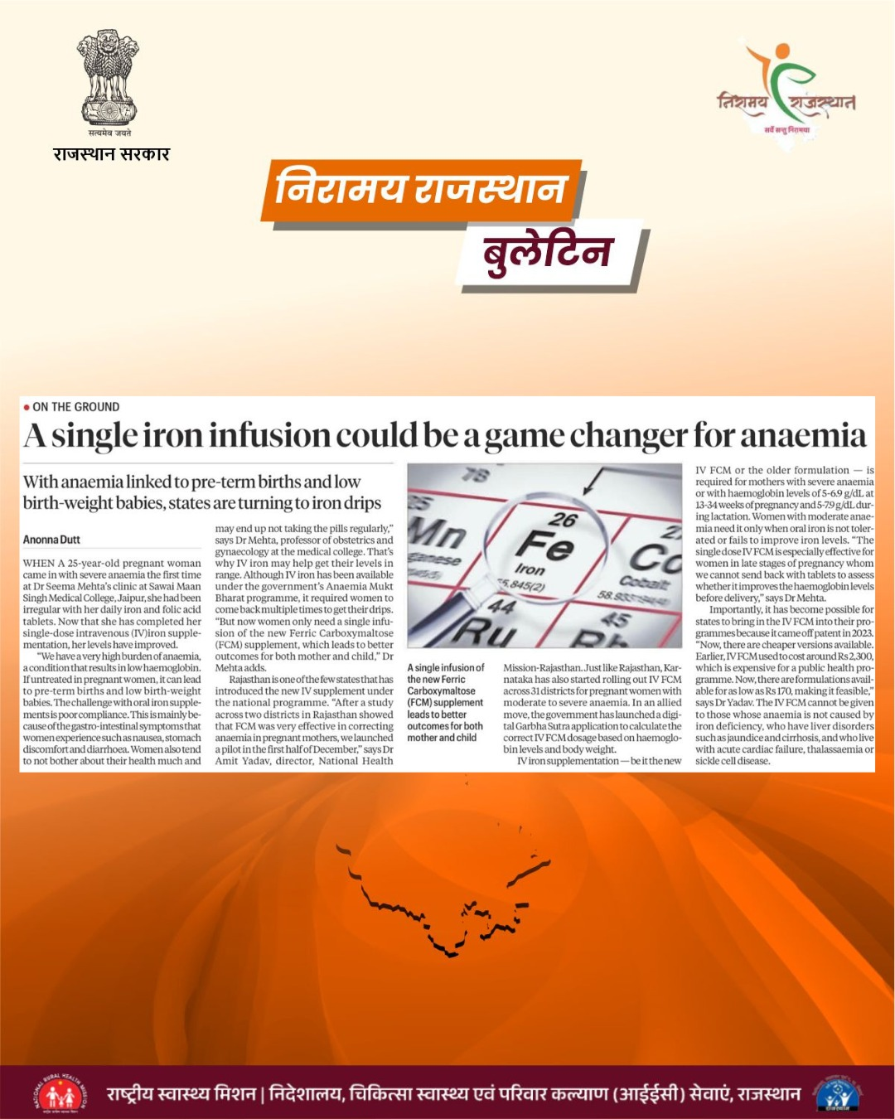

We solicit your feedback:
Editing and Compilation by: Archana Saxena, JTA; IT support: Mohit Dhonkeriya;
Mentored by: Dr Bharti Sharma, Faculty-Gynaecology, SIHFW
State Institute of Health & Family Welfare
Jhalana Institutional Area, South of Doordarshan Kendra Jaipur (Raj)
Phone-2706534
E-mail:-sihfwraj@ymail.com; Website: www.sihfwrajasthan.com

